SỞ GD&ĐT THÁI NGUYÊN  TRƯỜNG THPT  LƯƠNG NGỌC QUYẾN  ------------------ | KIỂM TRA HỌC KỲ I NĂM HỌC 2015-2016  MÔN TIẾNG ANH THÍ ĐIỂM – LỚP 10  Thời gian làm bài: 45 phút  (Không kể thời gian giao đề)

ĐIỂM | GIÁM KHẢO SỐ 1  (Họ tên, chữ ký) | GIÁM KHẢO SỐ 2  (Họ tên, chữ ký) | MÃ ĐỀ | SỐ PHÁCH
 |  |  | 376

SECTION A: LISTENING (15 POINTS)
PART 1: Listen and tick (v) the box. There is one example.
0. Where's the new DVD?
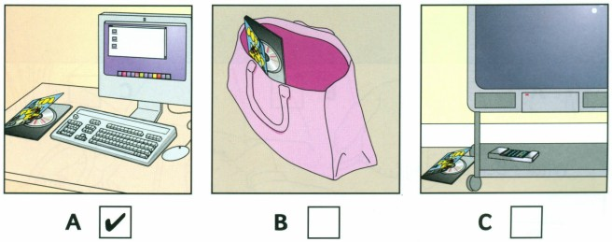
1. Which book did John buy?
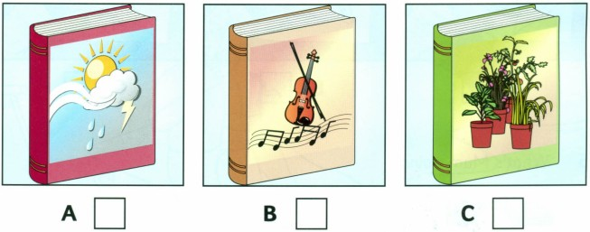
2. What does Sally want to do?
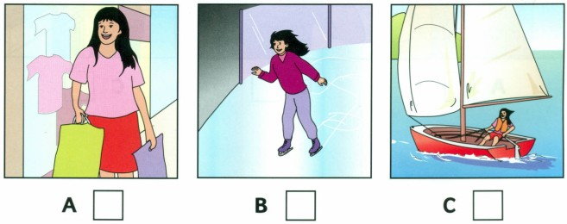
3. What's in the playground?
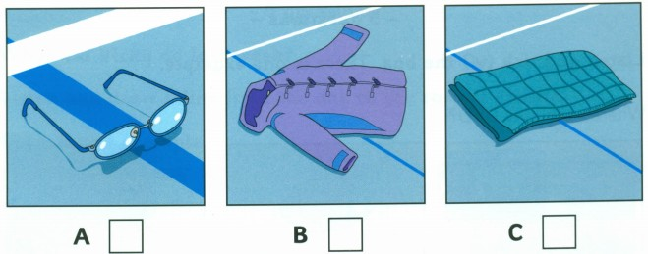
4. What's Ben drawing?
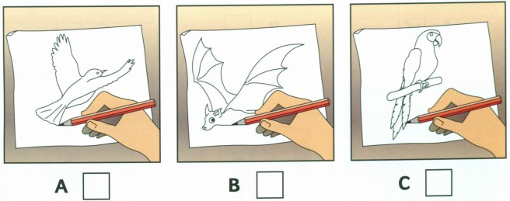
5. What's Mum doing?
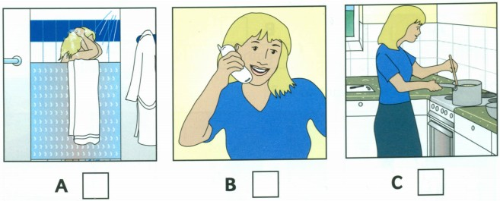
PART 2: Listen and write one missing word for each space below.
REDBRIDGE SPORTS CENTRE
(0) – Name: ………Lucy Flynn……………..
(1) – Which class? ………………………………….
(2) – When? …………………………………
(3) – Name of teacher? ………………………………..
(4) – Comes to Centre by: ………………………………
(5) – Favourite sport: ………………………………..

PART 3: Listen to the passage and choose the correct answer.
1. When was Picasso born?
A. In 1881 B. In 1896 C. In 1973
2. Picasso received artistic training from his father at ………………………
A. thirteen B. seven C. thirty
3. How many works of art did Picasso produce?
A. 50.000 B. 1.885 C. 1.973
4. When did Picasso die?
A. In 1937 B. In 1973 C. In 1993
5.Where did Picasso die?
A. In Malaga B. In Barcelona C. In Mougins
SECTION B : PHONETICS - VOCABULARY - LANGUAGE FOCUS (17 POINTS)
Choose the word which has the underlined part pronounced differently from the rest.
1. A. lung B. nurture C. muscle D. brush
2. A. different B. critical C. intestine D. dining table
Choose the word whose main stressed syllable is different from the rest.
3. A. nervous B. prevent C. healthy D. system
4. A. grocery B. memory C. incredible D. balance
Choose A, B, C, or D that best completes each unfinished sentence.
5. Peole tend to live in…………family which consist of parents and children.
A. blended B. nuclear C. extended D. single-parent
6. “Who……………..?” “…………………to get through to Misaki”
A. do you phone/ I’m trying B. are you phoning/ I’m trying
C. are you phoning/ I try D. do you phone/ / I try
7. I ……………….one of my special desserts for dinner, if you like.
A. make B. am going to make C. will make D. am making
8. the next train to Dublin ………….at 4:45. ( station announcement)
A. will leave B. is leaving C. is going to to leave D. leaves
9. Mark is _________ with the volunteer work in this charity organization. He is not very ________ about getting a paid job next time.
A. disappointed/ hopeful B. disappointed/ hopeless
C. disappointing/ hopefulness D. disappointing/ hopes
10. It is__________.that controls all the organs in the body.
A. heart B.brain C. spine D. nerves
11. __________takes place when the female provides the main source of income for the family
A. Breadwinner Mom B. Breadwinner Dad
C. Breadwinner D. Breadwinner male
12. the ____________system is to process the nutrients absorbed from the small intestine.
A. Respiratory B. Circulatory C. Digestive D. Skeletal
13. Students should have their eyes ____________ regularly.
A. tested B. to test C. test D. testing
Error identification.
14. Roles in homemaking and breadwinning can share by family members.
A B C D
15. It didn’t take her much time to do the laundry because she has a washing machine.
A B C D
16. I shall contact you as soon as they will phone me.
A B C D
17. Our new neighbour is a bored man.
A B C D

SECTION C: READING (8 POINTS)
Read the passage and choose the best answer:
FOOD AROUND THE WORLD
It isn't amazing how much time we spend talking about food? "Have you ever eaten ...?", "What do you have for lunch?" and so on. And yet, when you travel from one county to another, you find that people have quite different feelings about food. People often feel that what they eat is normal, and what other people eat is strange and silly. In most parts of Asia, for example, no meal is complete without rice. In England, people eat potatoes every day. In the Middle East, bread is the main part of every meal. Eating becomes a habit which is difficult to change. Americans like to drink a lot of orange juice and coffee. The English drink tea four or five times a day. Australians drink large amounts of beer and the French drink wine every day.
The sorts of meat people like to eat also differ from one country to another. Horse meat is thought to be delicious in France. In Hong Kong, some people enjoy eating snakes. New Zealanders eat sheep, but never eat goat meat. The Japanese don’t like to eat sheep meat because of its smell, but they enjoy eating raw fish. So it seems that although eating is a topic that we can talk about for hours, there is a little common sense in what we say about it. People everywhere enjoy what they have always eaten, and there is very little we can do to change our eating habit.
1. What is the main idea of the text?
A. People have the same feelings about food.
B. People think about food differently.
C. People think that no meal is perfect without rice.
2. According to the writer, where is bread the main food?
A. In Asia B. In Japan C. In Middle East
3. Which of these people drink wine every day?
A. Americans B. Australians C. The French
4. Why are the Japanese not interested in sheep meat?
A. They don't like its smell. B. It tastes bad. C. Horse meat and goat meat are popular.
5. In which country do people often drink beer?
A. France B. Australia C. England
6. Which is popular food in Japan?
A. Fish B. Horse meat C. Goat meat
7. How does the writer conclude about our eating habit?
A. Our eating habit is difficult to change.
B. People everywhere enjoy eating new food.
C. We can change our eating habit easily.
8. Match the countries and their popular foods or drinks:
ENGLAND, FRANCE, AMERICA, THE MIDDLE EAST, ASIA, ENGLAND.
1. 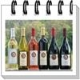2.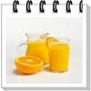 3.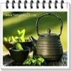4. 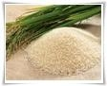5.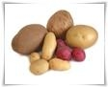6.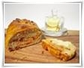
SECTION D: WRITING (10 POINTS)
I. Rewrite the following sentences using the words given so that it means exactly the same as the first sentence.
1. The gardener waters the flowers every evening.
→The flowers _____________________________________________________________
2. My nephew often flied a kite in this field when he was a child.
-> My nephew used _________________________________________________________
3. I last saw my cousin two years ago.
-> I haven’t ________________________________________________________________
4. It is believed that the wanted man is living in New York
→The wanted man _________________________________________________________
II. Writing a paragraph of about 60 words about how do you divide household duties in your family. (6 points)
__________________________________________________________________________________________________________________________________________________________________________________________________________________________________________________________________________________________________________________________________________________________________________________________________________________________________________________________________________________________________________________________________________________________________________________________________________________________________________________________________________________________________________________________________________________________________________________________________________________________________________________________________________________________________________________________________________________________________________________________________________________________________________________________________________________________________________________________________________________________________________________________________________________________________________________________________________________________________________________________________________________________________________________________________________________________________________________________________________________________________________________________________________________________________________________________________________________

______ THE END ______
SỞ GD&ĐT THÁI NGUYÊN  TRƯỜNG THPT  LƯƠNG NGỌC QUYẾN  ------------------ | ĐÁP ÁN ĐỀ KIỂM TRA HỌC KỲ I  NĂM HỌC 2015-2016  MÔN TIẾNG ANH THÍ ĐIỂM– LỚP 10  MÃ ĐỀ 367

SECTION A: LISTENING (15 points)
I.
1. B | 2. A | 3. C | 4. B | 5. A
II.
1. swimming | 2. afternoon | 3. Hart | 4. her Dad’s car | 5. tennis
III.
1. A | 2. B | 3. A | 4. B | 5. C

SECTION B: PHONETICS- VOCABULARY- LANGUAGE FOCUS (17 points)
1. B | 2. D | 3. B | 4. C | 5. B | 6. B
7. C | 8. D | 9. A | 10. B | 11. A | 12. C
13. A | 14. C | 15. A | 16. C | 17. D

SECTION C: READING (8 points)
1. B | 2. C | 3. C | 4. A | 5. B | 6. A | 7. A
8.
1 | 2 | 3 | 4 | 5 | 6
FRANCE | AMERICA | ENGLAND | ASIA | ENGLAND | THE MIDDLE EAST

SECTION D: WRITING (10 points)
I. Rewrite sentences. (4 points)
1. The flowers are watered by the gardener every evening.
2. My nephew used to fly a kite in this field when he was a child.
3. I haven’t seen my cousin for two years.
4. The wanted man is believed to be living in New York.
II. Write a paragraph. ( 6 points)
- Vocabulary
- Structures
- Content
- Format
TOTAL: 50 POINTS: 5 = 10

